Employee Management System

Code:

EmployeeManagementSystem.java:

package com.amdocs;

import org.springframework.boot.SpringApplication;
import org.springframework.boot.autoconfigure.SpringBootApplication;

@SpringBootApplication
public class EmployeeManagementApplication {

public static void main(String[] args) {
SpringApplication.run(EmployeeManagementApplication.class, args);
}

}

Com.amdocs.entity
Employee

package com.amdocs.entity;

import jakarta.persistence.Entity;
import jakarta.persistence.GeneratedValue;
import jakarta.persistence.GenerationType;
import jakarta.persistence.Id;

@Entity
public class Employee {
@Id
@GeneratedValue(strategy=GenerationType.AUTO)
private Long empId;
private String empFirstName;
private String empLastName;
private String empEmail;
public Employee() {
super();
// TODO Auto-generated constructor stub
}
public Employee(Long empId, String empFirstName, String empLastName, String empEmail) {
super();
this.empId = empId;
this.empFirstName = empFirstName;
this.empLastName = empLastName;
this.empEmail = empEmail;
}
public Long getEmpId() {
return empId;
}
public void setEmpId(Long empId) {
this.empId = empId;
}
public String getEmpFirstName() {
return empFirstName;
}
public void setEmpFirstName(String empFirstName) {
this.empFirstName = empFirstName;
}
public String getEmpLastName() {
return empLastName;
}
public void setEmpLastName(String empLastName) {
this.empLastName = empLastName;
}
public String getEmpEmail() {
return empEmail;
}
public void setEmpEmail(String empEmail) {
this.empEmail = empEmail;
}
@Override
public String toString() {
return "Employee [empId=" + empId + ", empFirstName=" + empFirstName + ", empLastName=" + empLastName
+ ", empEmail=" + empEmail + "]";
}

}

Com.amdocs.repo
EmployeeRepository

package com.amdocs.repo;

import org.springframework.data.jpa.repository.JpaRepository;

import com.amdocs.entity.Employee;

public interface EmployeeRepository extends JpaRepository<Employee,Long>{

}

Com.amdocs.service
EmployeeService

package com.amdocs.service;

import java.util.List;

import com.amdocs.entity.Employee;

public interface EmployeeService {
Employee saveEmployee(Employee employee);

List<Employee> fetchAllEmployees();

Employee getEmployeeById(Long id);

Employee updateEmployeeById(Long id, Employee employee);

String deleteEmployeeById(Long id);

}

EmployeeServiceIMPL
package com.amdocs.service;

import java.util.List;
import java.util.Objects;
import java.util.Optional;

import org.springframework.beans.factory.annotation.Autowired;
import org.springframework.stereotype.Service;

import com.amdocs.entity.Employee;
import com.amdocs.repo.EmployeeRepository;

@Service
public class EmployeeServiceIMPL implements EmployeeService {
@Autowired
private EmployeeRepository employeeRepository;

@Override
public Employee saveEmployee(Employee employee) {
return employeeRepository.save(employee);
}

@Override
public List<Employee> fetchAllEmployees() {
List<Employee> allEmployees = employeeRepository.findAll();
return allEmployees;
}

@Override
public Employee getEmployeeById(Long id) {
return employeeRepository.findById(id).get();
}

@Override
public Employee updateEmployeeById(Long id, Employee employee) {
Optional<Employee> emp = employeeRepository.findById(id);

if(emp.isPresent()) {
Employee existingEmployee = emp.get();

if(Objects.nonNull(employee.getEmpFirstName()) && !"".equalsIgnoreCase(employee.getEmpFirstName())) {
existingEmployee.setEmpFirstName(employee.getEmpFirstName());
}
if(Objects.nonNull(employee.getEmpLastName()) && !"".equalsIgnoreCase(employee.getEmpLastName())) {
existingEmployee.setEmpLastName(employee.getEmpLastName());
}
if(Objects.nonNull(employee.getEmpEmail()) && !"".equalsIgnoreCase(employee.getEmpEmail())) {
existingEmployee.setEmpEmail(employee.getEmpEmail());
}

return employeeRepository.save(existingEmployee);
}

return null;
}

@Override
public String deleteEmployeeById(Long id) {
if(employeeRepository.findById(id).isPresent()) {
employeeRepository.deleteById(id);
return "Employee Deleted Successfully!";
}
return "No such employee in the database";
}
}

Com.amdocs.controller
MyController:

package com.amdocs.controller;

import java.util.List;

import org.springframework.beans.factory.annotation.Autowired;
import org.springframework.web.bind.annotation.DeleteMapping;
import org.springframework.web.bind.annotation.GetMapping;
import org.springframework.web.bind.annotation.PathVariable;
import org.springframework.web.bind.annotation.PostMapping;
import org.springframework.web.bind.annotation.PutMapping;
import org.springframework.web.bind.annotation.RequestBody;
import org.springframework.web.bind.annotation.RestController;

import com.amdocs.entity.Employee;
import com.amdocs.service.EmployeeService;

@RestController
public class MyController {
@Autowired
private EmployeeService employeeService;

@PostMapping("/employee")
public Employee saveEmployee(@RequestBody Employee employee) {
return employeeService.saveEmployee(employee);
}

@GetMapping("/employee")
public List<Employee> getAllEmployees() {
return employeeService.fetchAllEmployees();
}

@GetMapping("/employee/{id}")
public Employee getEmployeeById(@PathVariable("id") Long id) {
return employeeService.getEmployeeById(id);
}

@PutMapping("/employee/{id}")
public Employee updateEmployeeById(@PathVariable("id") Long id, @RequestBody Employee employee) {
return employeeService.updateEmployeeById(id, employee);
}

@DeleteMapping("/employee/{id}")
public String deleteEmployee(@PathVariable("id") Long id) {
return employeeService.deleteEmployeeById(id);
}

}

Screenshots Of Output:
-MySql Workbench:
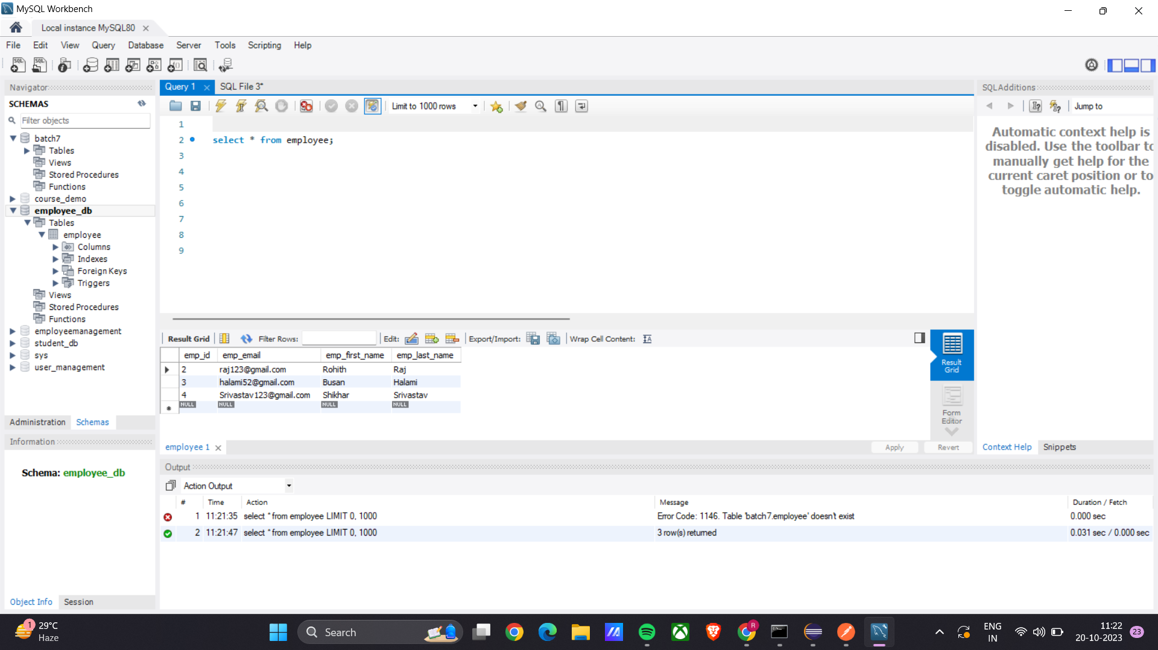

-GET:
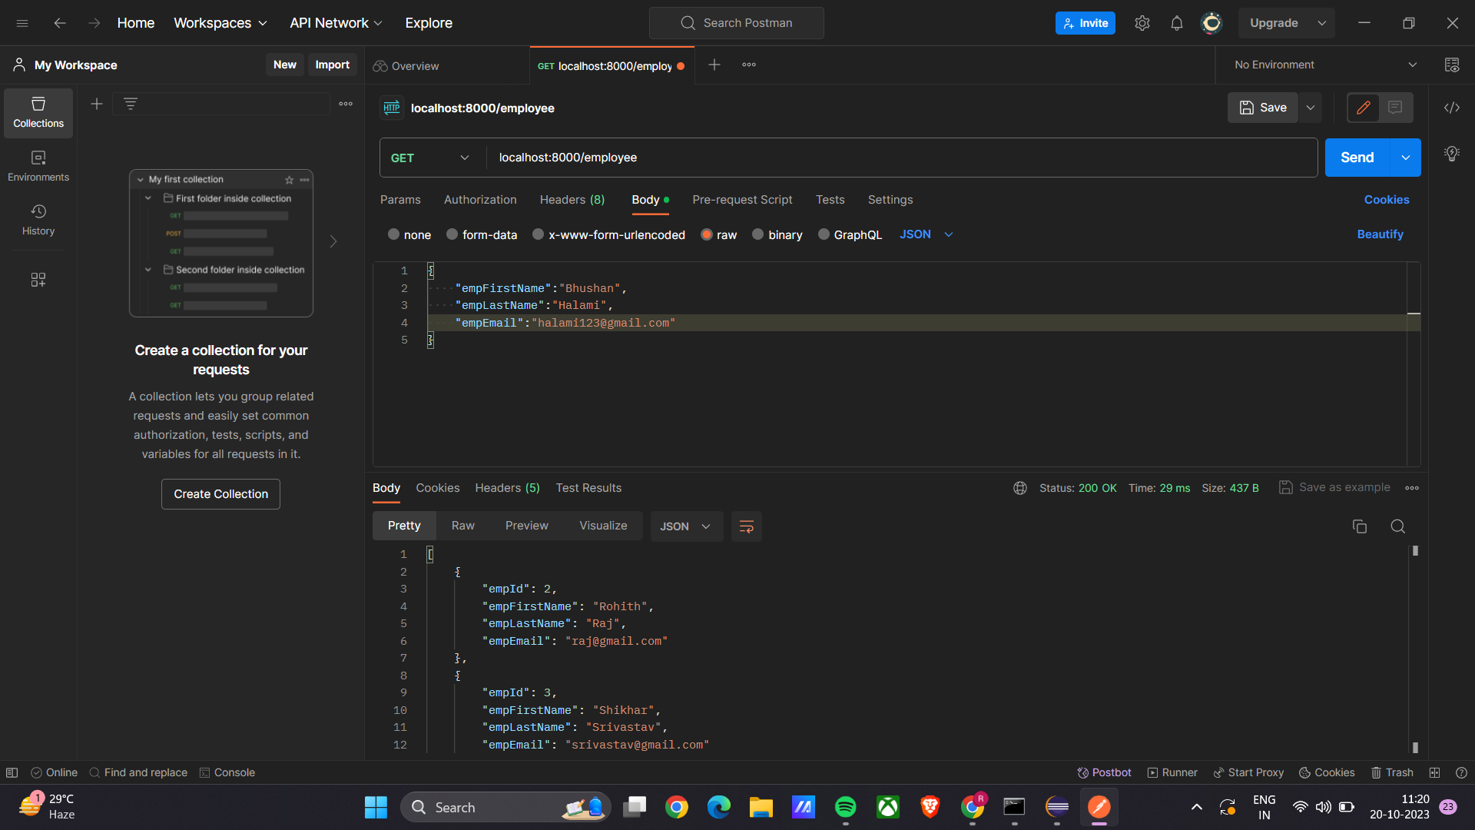

-POST
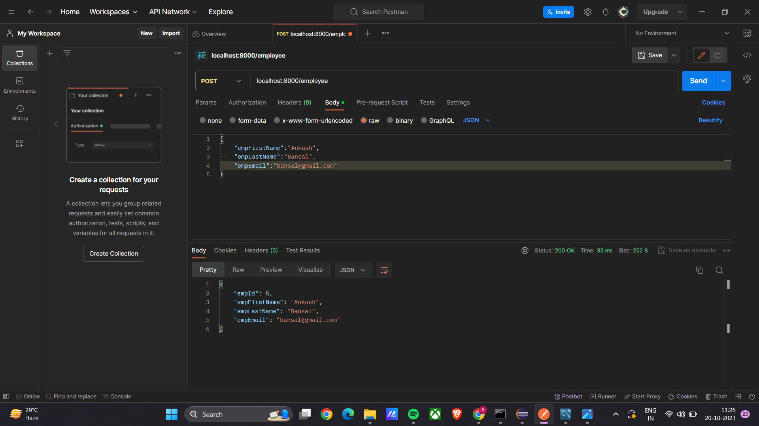

-PUT
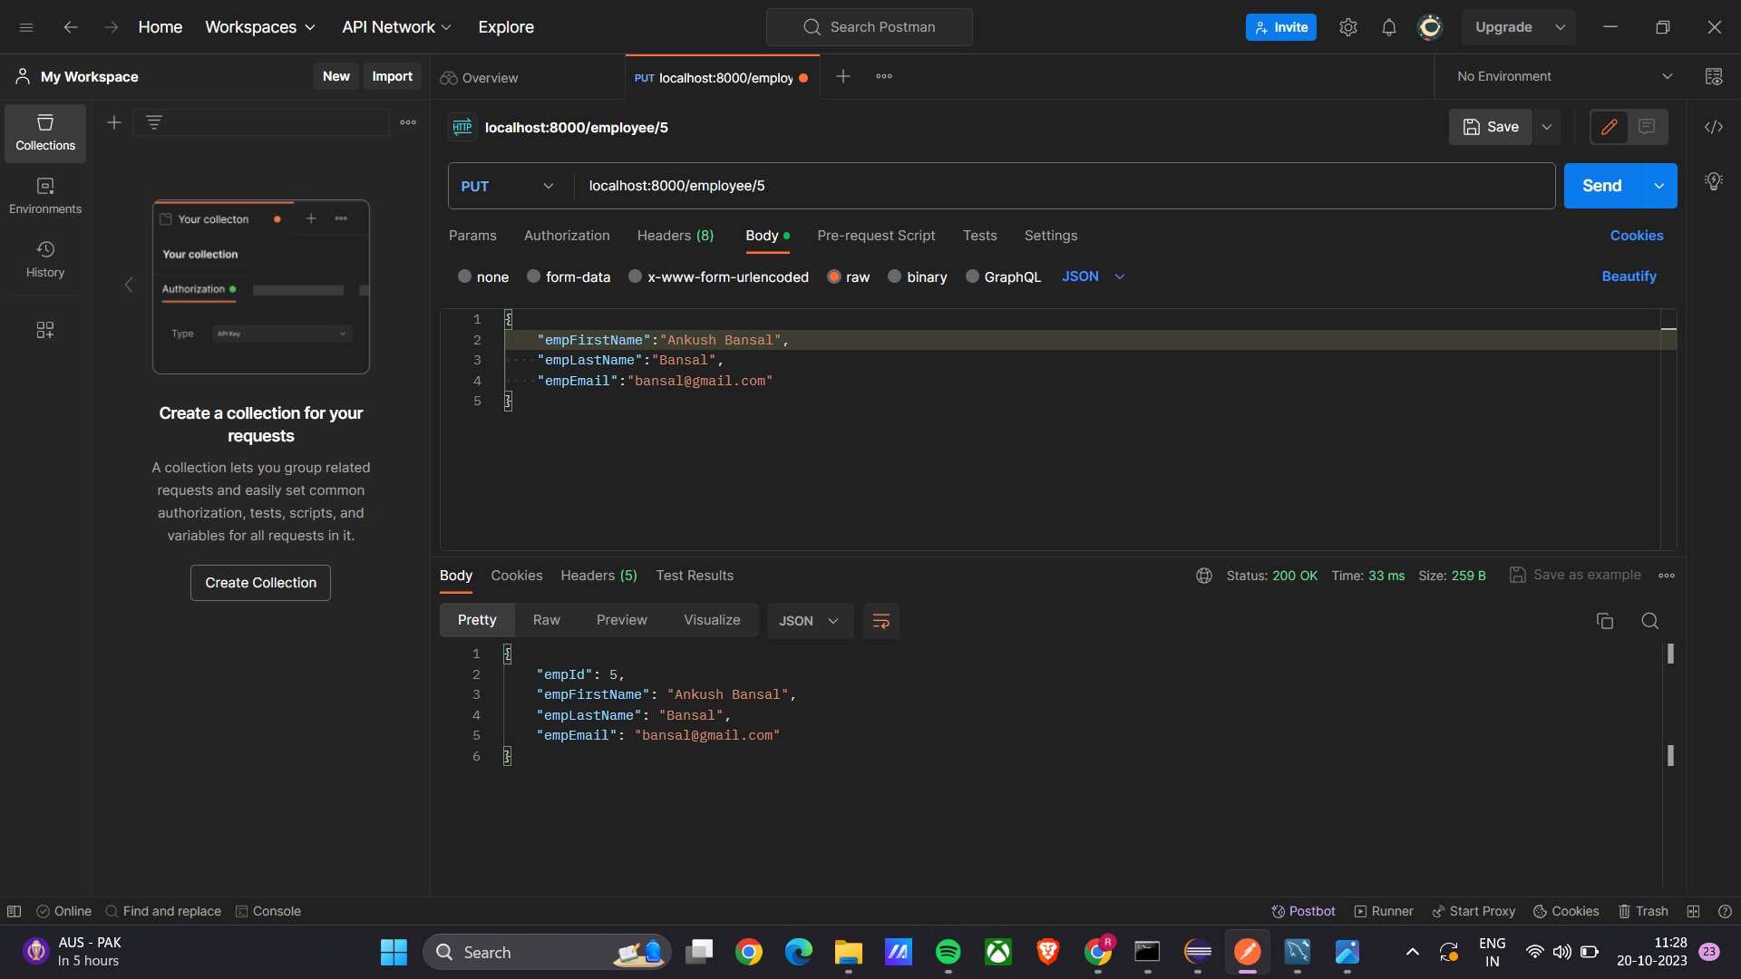

-DELETE
